|  |  |
| --- | --- |
| **EX.NO: 02** | **CONTROL STATEMENTS** |
| **DATE:** |

**PROGRAM 1:**

Develop a python program for finding the absolute value of a given number. This is always measured as positive number. This number is the distance of given number from the 0(Zero). The input value may be integer, float or complex number in Python. The absolute value of given number may be integer or float.

num = input("Enter a number: ") num = float(num)

print("Absolute value:", abs(num))

**OUTPUT:**

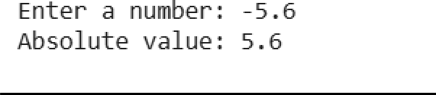

**PROGRAM 2:**

Calculate the Total selling price after levying the GST (Goods and Service Tax) as CGST and SGST on sale. CGST (Central Govt. GST), SGST (State Govt. GST) .

|  |  |  |
| --- | --- | --- |
| **Sale amount** | **CGST Rate** | **SGST Rate** |
| 0-50000 | 5% | 5% |
| Above 50000 | 18% | 18% |

sale = float(input("Enter sale amount: ")) if sale <= 50000:

gst_rate = 5 else:

gst_rate = 18

cgst = (gst_rate / 100) * sale sgst = (gst_rate / 100) * sale total = sale + cgst + sgst

print("Total price after GST:", total)

**OUTPUT:**



**PROGRAM 3:**

Write a Python program to construct the following pattern, using a nested for loop.

*

* *

* * *

* * * *

* * * * *

* * * *

* * *

* *

*

for i in range(1, 6): print("* " * i)

for i in range(4, 0, -1): print("* " * i)

**OUTPUT:**

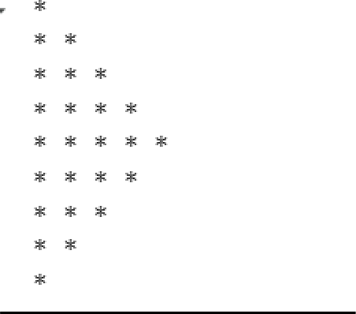

**PROGRAM 4:**

Write a Python program to guess a number between 1 and 9.

Note: The User is prompted to enter a guess. If the user guesses wrong, then the prompt appears again until the guess is correct. On a successful guess, the user will get a "Well guessed!" message, and the program will exit.

import random

num = random.randint(1, 9) while True:

guess = int(input("Guess a number (1 to 9): ")) if guess == num:

print("Well guessed!") break

**OUTPUT:**

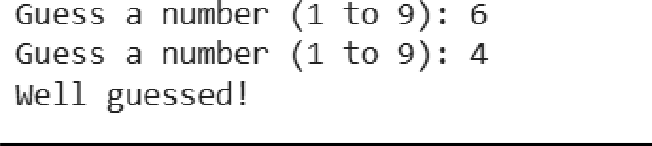

**PROGRAM 5:**

You have two streaming subscriptions and want to find out how much you spend each month and how much you could save if you switch to paying annually. Each subscription has a monthly cost and offers a discounted annual rate.

Write a Python program to calculate the total monthly cost for both subscriptions, the total annual cost if you continue paying monthly, and compare this with the yearly rates you would pay if you switch to annual payments. Finally, choose the yearly payment option to see how much you could save.

Test Case: Input:

Service 1 = $10/month Service 2 = $12/month

Annual Discount for Service 1 = $100 Annual Discount for Service 2 = $120

Expected Output:

Monthly Total: $22.00

Total Annual Cost without Discount: $264.00 Total Annual Discounted Cost: $220.00 Total Savings: $44.00

service1_month = 10

service2_month = 12

service1_year = 100

service2_year = 120

monthly_total = service1_month + service2_month print("Monthly Total: $", monthly_total) annual_cost = monthly_total * 12

print("Total Annual Cost without Discount: $", annual_cost) annual_discounted_cost = service1_year + service2_year print("Total Annual Discounted Cost: $", annual_discounted_cost) savings = annual_cost - annual_discounted_cost

print("Total Savings: $", savings)

**OUTPUT:**

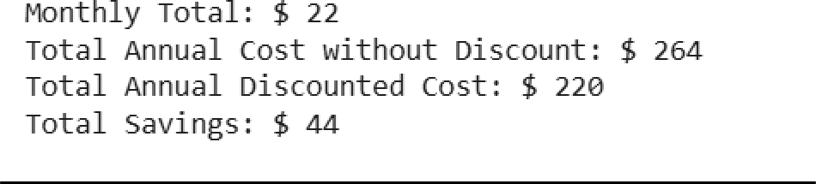

**PROGRAM 6:**

Write a Python program that iterates through integers from 1 to 50. For each multiple of three, print "Fizz" instead of the number; for each multiple of five, print "Buzz". For numbers that are multiples of both three and five, print "FizzBuzz".

for i in range(1, 51):

if i % 3 == 0 and i % 5 == 0: print("FizzBuzz")

elif i % 3 == 0: print("Fizz") elif i % 5 == 0: print("Buzz")

else:

print(i)

**OUTPUT:**

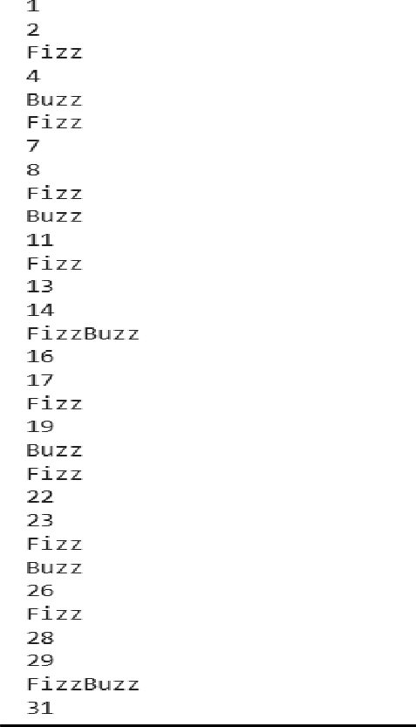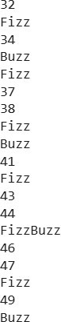

**PROGRAM 7:**

Write a Python program that takes two digits, m (row) and n (column) as input and generates a two-dimensional array. The element value in the i-th row and j-th column of the array should be i*j.

Note :

i = 0,1.., m-1

j = 0,1, n-1.

Test Data : Rows = 3, Columns = 4

Expected Result : [[0, 0, 0, 0], [0, 1, 2, 3], [0, 2, 4, 6]]

m = int(input("Enter number of rows: "))

n = int(input("Enter number of columns: ")) array = []

for i in range(m): row = []

for j in range(n): row.append(i * j)

array.append(row) print(array)

**OUTPUT:**

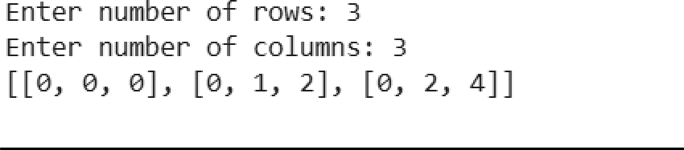

**PROGRAM 8:**

Write a Python program for Grade Classification Scenario: A school system classifies grades as follows:

A (90 and above)

B (70 to 89)

C (50 to 69)

D (below 50)

Question: What grade will be assigned to a student who scores 85? If the score is 92, what grade will the program output

**OUTPUT:**

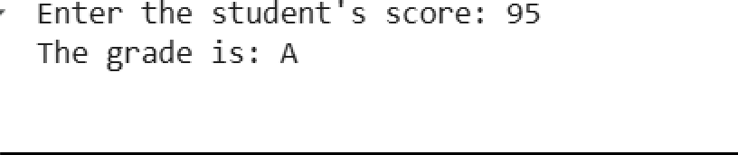

**PROGRAM 9:**

Write a program that prints the multiplication table of a user-entered number up to 10.

**OUTPUT:**

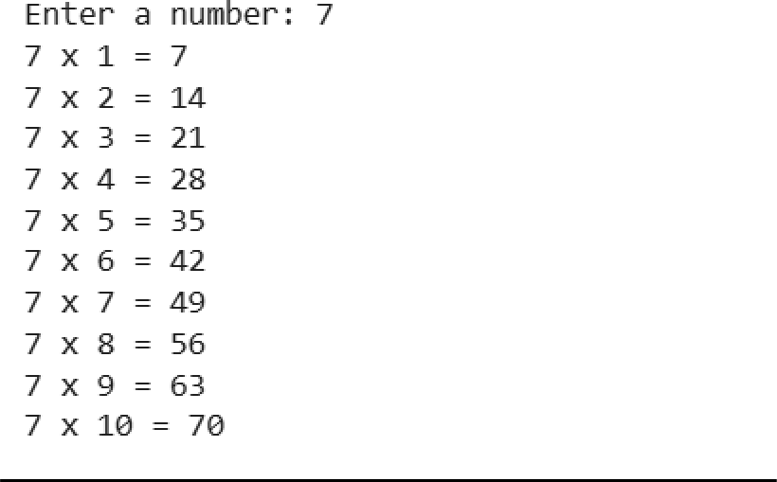

**PROGRAM 10:**

Write a Python program to check the validity of passwords input by users. Validation :

At least 1 letter between [a-z] and 1 letter between [A-Z]. At least 1 number between [0-9].

At least 1 character from [$#@]. Minimum length 6 characters. Maximum length 16 characters.

import re

password = input("Enter password: ") if (6 <= len(password) <= 16

and re.search("[a-z]", password) and re.search("[A-Z]", password) and re.search("[0-9]", password) and re.search("[$#@]", password)): print("Password is valid!")

else:

print("Password is invalid!")

**OUTPUT:**



|  |  |  |
| --- | --- | --- |
| **DEPARTMENT OF CSE** | | |
| Program | 10 |  |
| Output | 5 |  |
| Viva-Voce | 5 |  |
| Total | 20 |  |